Assignment 3 Part 2 : Attribution modeling and Budget Optimization.

|  |  |
| --- | --- |
| **Summary** | In this codelab, we have build and analyzed the attribution models |
| **URL** |  |
| **Category** | Document |
| **Environment** | Viola dashboard, jupyter notebook |
| **Status** | Assignment |
| **Feedback Link** |  |
| **Author** | Team 4 |

[Introduction](https://docs.google.com/document/d/15umQeR3xet5346HTcWMZG98zRD-vkvjZ6ThDJfoIdcs/edit#heading=h.ok7k5uux6)

Applying LTA and Logistic regression models and comparing them with other models used in the industry:

1) Time-decay attribution: gives more credit to the touchpoints that are closer in time to the conversion.

2) Linear attribution: gives equal credit to all touchpoints in the journey.

3) U-shaped attribution: gives most of the credit to the first and last touchpoints, and some credit to intermediate touchpoints.

4) First-touch attribution: gives all credit to the first touchpoint in the journey.

# 

# Data exploration

The data is randomly sampled for 20 campaigns by down sampling the data filtered out journeys with just one event to focus on sequence analysis. That means every user id has only one campaign assigned to it.

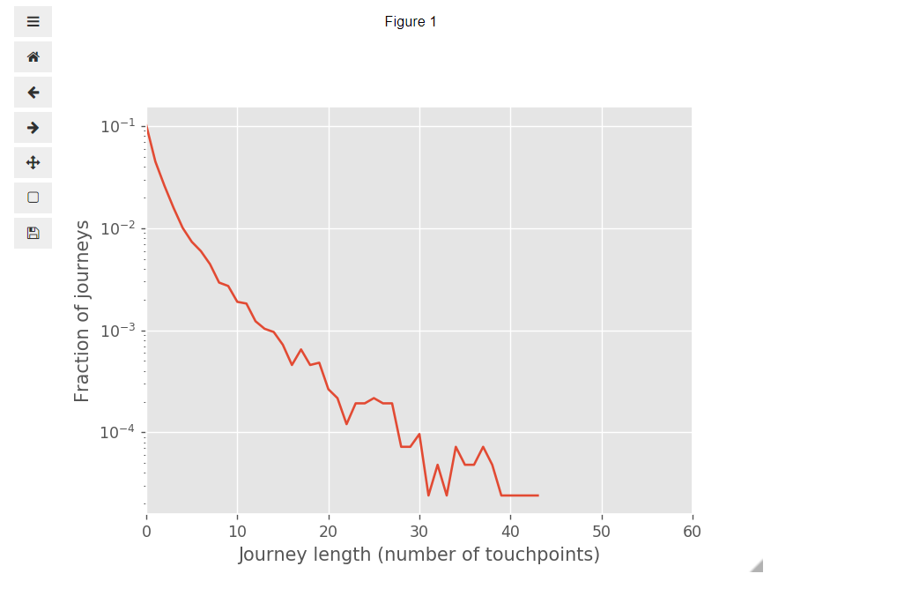

After exploring data it is found that there are maximum around 44 touchpoints that are being exposed to different journey id’s

# Last Touch Attribution

This model gives all credit to the last touchpoint in the journey.

Here we consider the timestamp_norm column to find which is the last journey in the campaign that is converted and get results as follows.

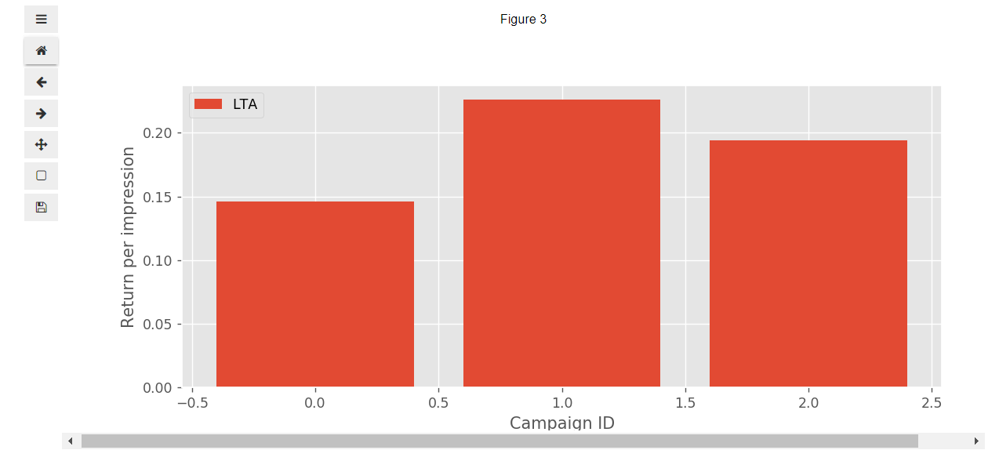

# First Touch Attribution

This model gives all credit to the last touchpoint in the journey.

Using timestamp_norm we get the first journey id for the given campaign for the converted journey.

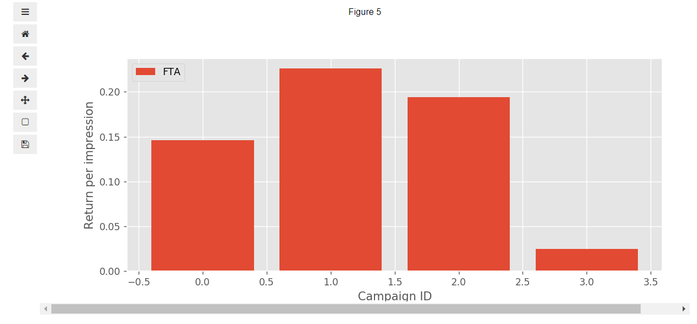

# Linear Attribution

This model gives equal credit to the last touchpoint in the journey.

Using timestamp_norm we get the first journey id for the given campaign for the converted journey.

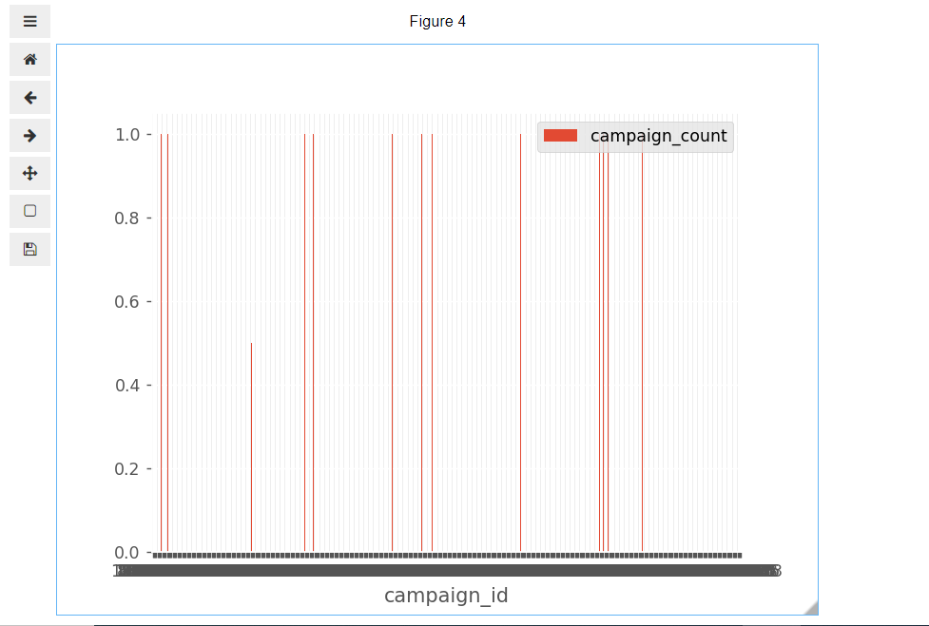

# U-Shaped Attribution

This model gives equal credit to the last touchpoint and first touchpoint and equal credit to the intermediate journey.

Using timestamp_norm we get the first journey id for the given campaign for the converted journey.

## 

# Logistic Regression

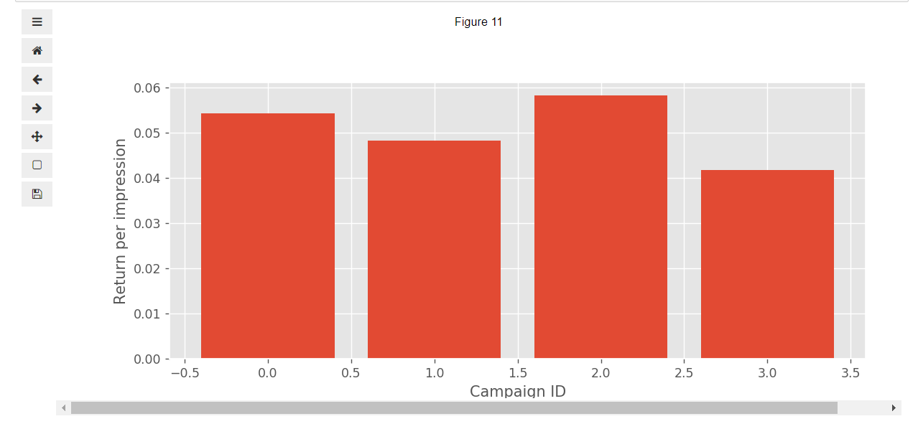

# Model Comparison

LTA and Keras Log Reg

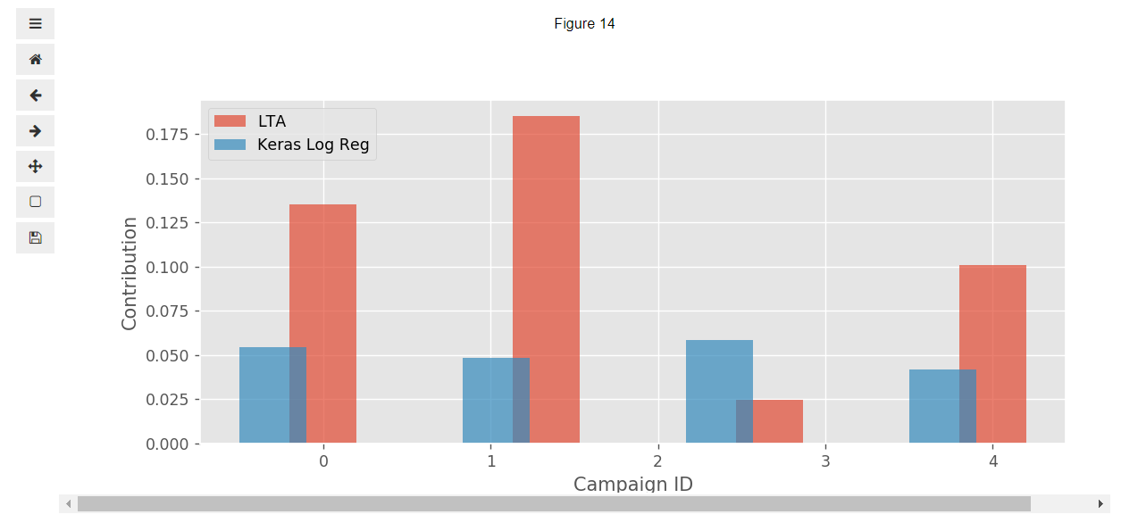

FTA Vs Keras

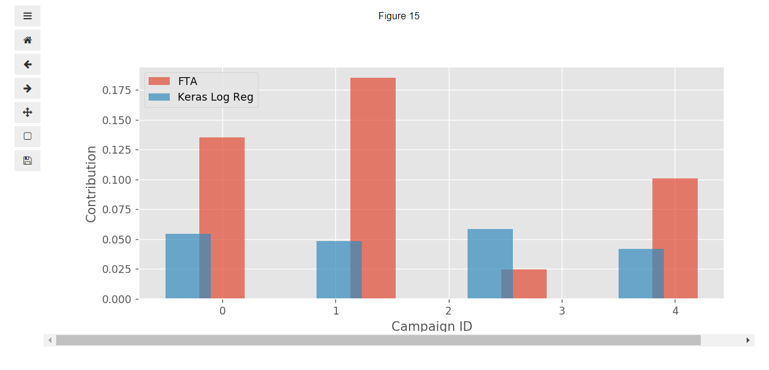

Linear vs Keras